**PR Assignment-2**

**G HAREESH**

**18MCMB15**

**M.TECH (IT)**

**1st question**

**def standerdize (data):**

mean = np.mean(data,axis=0)

std = np.std(data,axis=0)

return (data - mean) / std

**def getpca(k,data,get_eig = False):**

data = standerdize(data)

cov = np.cov(data.T)

eig_vals , eig_vecs = np.linalg.eig(cov)

eig_pairs = [(np.abs(eig_vals[i]),eig_vecs[:,i]) for i in range(len(eig_vals))] eig_pairs.sort(key = lambda k:k[0] , reverse = True)

mat = np.hstack([eig_pairs[i][1][:,np.newaxis] for i in range(k)])

if get_eig == True:

return eigen_vals , data.dot(mat)

return data.dot(mat)

**def getlda(k,data,datalabels):**

labels = np.unique(datalabels)

data = standerdize(data)

mean_vecs = []

mean_labels = []

for label in labels:

mean_vecs.append(np.mean(data[datalabels==label] , axis=0))

mean_labels.append(label)

d = data.shape[1]

S_W = np.zeros((d,d))

for label,mv in zip(labels,mean_vecs):

class_scatter = np.zeros((d,d))

for row in data[datalabels==label]:

row, mv = row.reshape(d, 1), mv.reshape(d, 1) class_scatter += (row-mv).dot((row-mv).T) S_W += class_scatter

"""for label,mv in zip(range(1, 4), mean_vecs):

class_scatter = np.cov(X_train_std[y_train==label].T)

S_W += class_scatter"""

mean_overall = np.mean(data, axis=0)

mean_overall = mean_overall.reshape(d,1)

S_B = np.zeros((d, d))

for label, mean_vec in zip(mean_labels,mean_vecs):

n = data[datalabels == label].shape[0]

mean_vec = mean_vec.reshape(d,1)

S_B += n * (mean_vec - mean_overall).dot((mean_vec - mean_overall).T)

eigen_vals, eigen_vecs = np.linalg.eig(np.linalg.inv(S_W) @ (S_B))

eigen_pairs = [(np.abs(eigen_vals[i]), eigen_vecs[:,i]) for i in range(len(eigen_vals))] eigen_pairs = sorted(eigen_pairs,key=lambda k: k[0], reverse=True) mat = np.hstack([eigen_pairs[i][1][:,np.newaxis] for i in range(k)])

return data.dot(mat)

**2nd Question:**

**Results :**

**(Snapshots of the Results TO view them completely Open Notebook)**

**PCA1 vs PCA3**

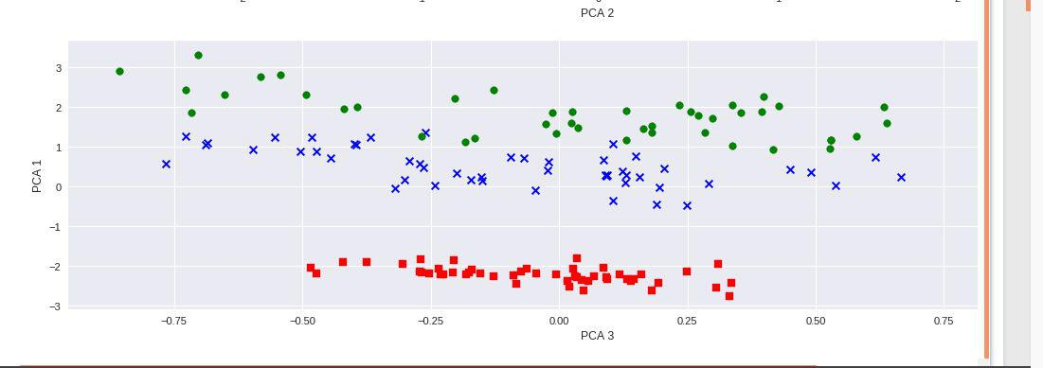

**PCA2 vs PCA3**

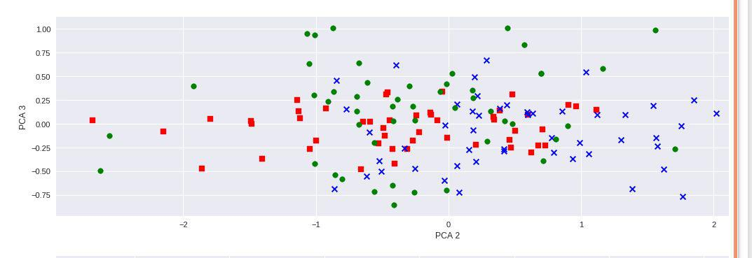

**PCA1 vs PCA2**

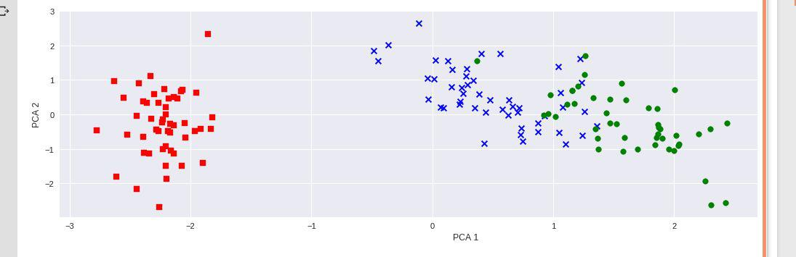

**LDA :**

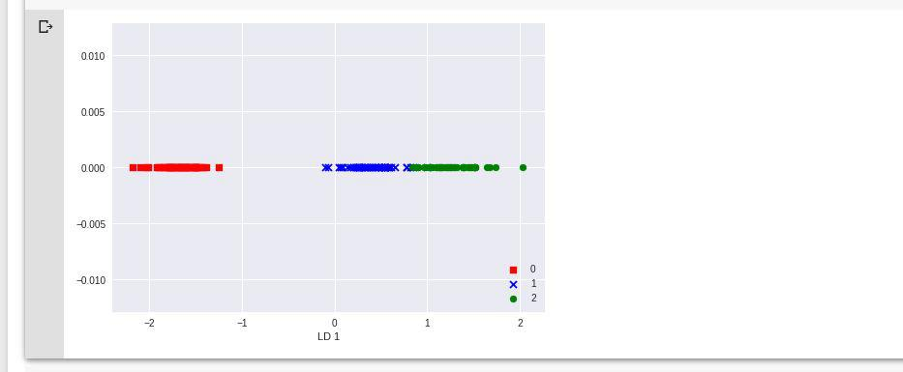

**Arcene :**

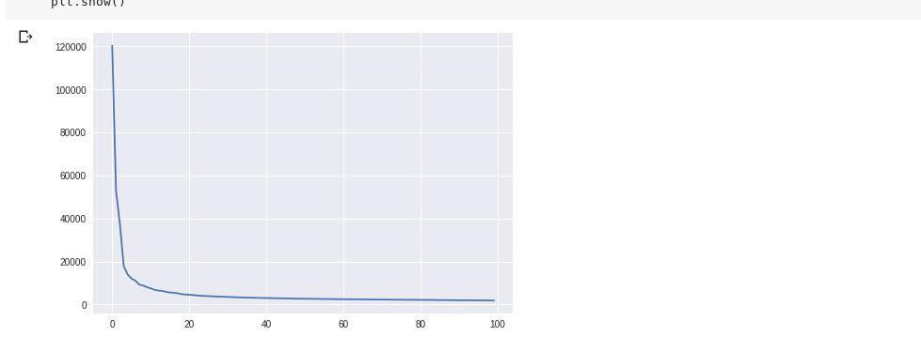

**3rd question**

**Libraries Used:**

import numpy as np

import pandas as pd

import matplotlib.pyplot as plt

**Dataset Used:**

UCI Arcene cancer dataset

**Analysis of components with respect to variance:** No of Components required for getting 0.85 variances are : 61 No of Components required for getting 0.90 variances are : 73 No of Components required for getting 0.95 variances are : 86 No of Components required for getting 0.99 variances are : 97

**Results:**

**Pca two principal component**

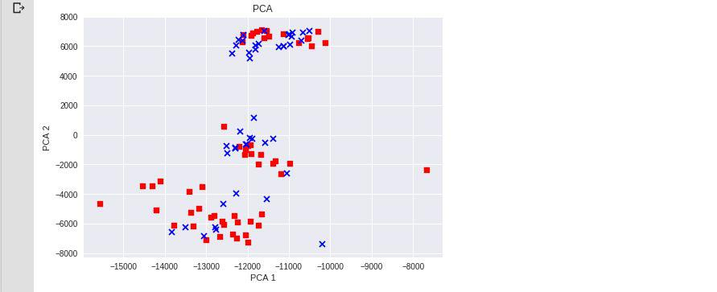

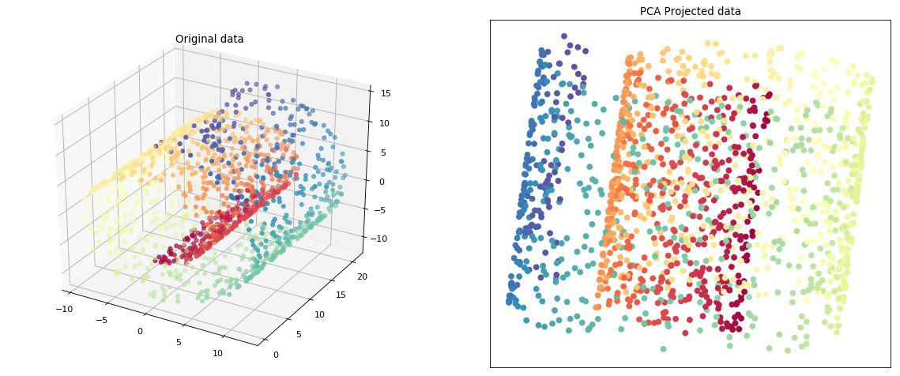**PCA**

**KPCA**

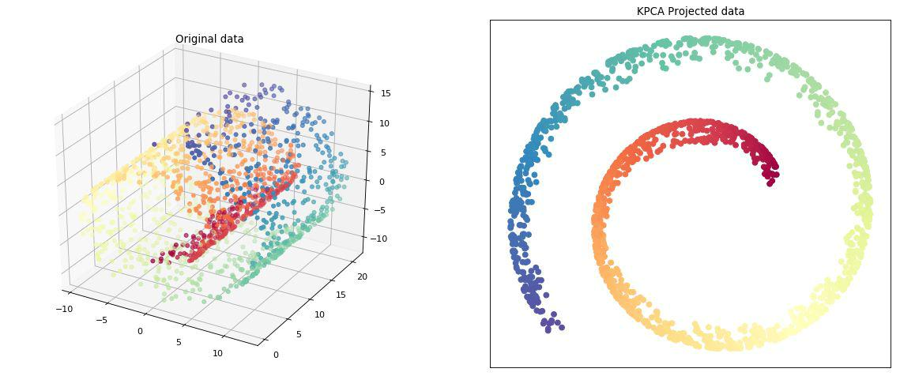

**LLE**

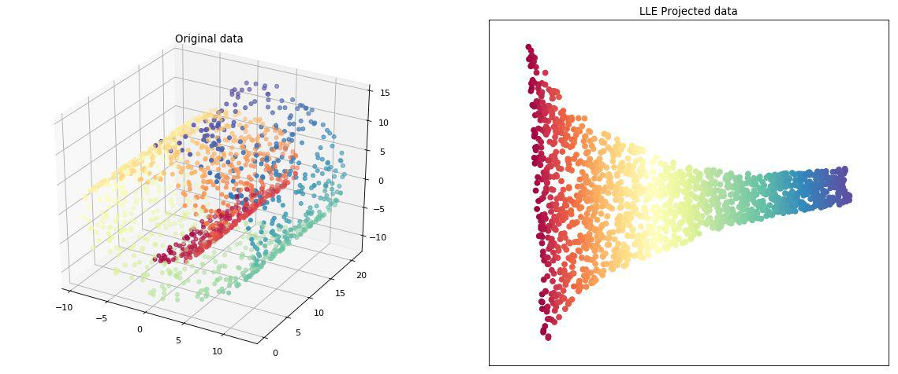

**4th Question**

**Dataset Used:** 3D swissroll dataset

**Results :**

**PCA**

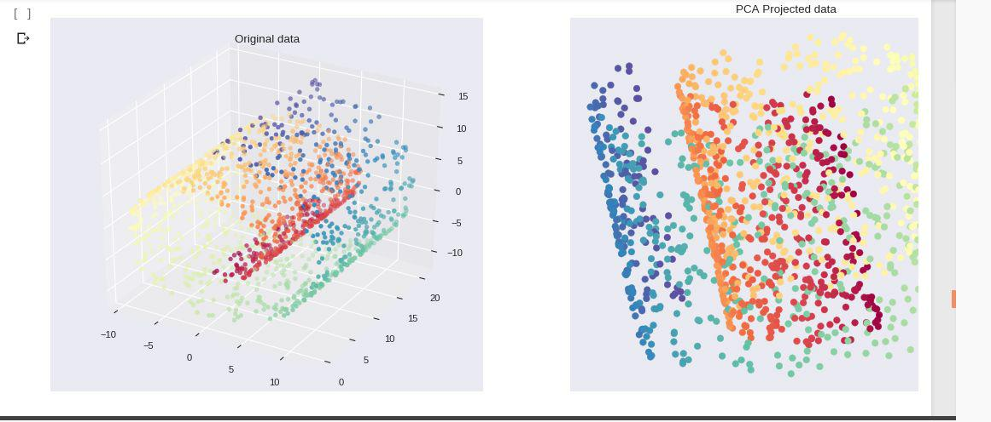

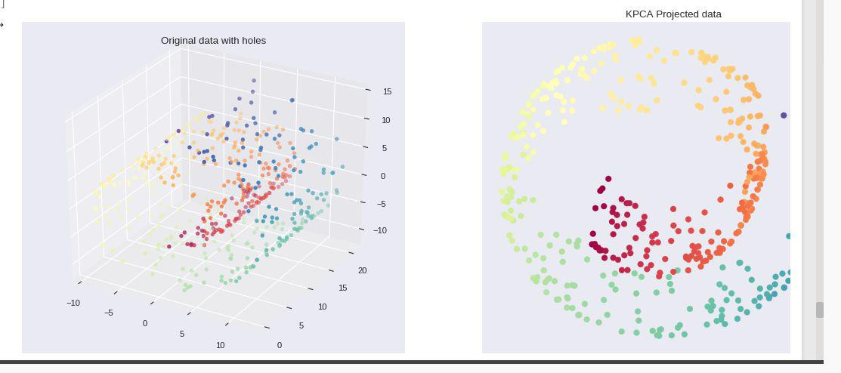**KPCA**

**LLE**

